**PIG installation**

**Step by Step Guide Presented By**



**PREREQUEST :**

**Running instance of Hadoop in any linux OS.**

**Pig installation steps are as given below:**

**Download Pig (0.12.0) Link:**

[**http://www.us.apache.org/dist/pig/pig-0.14.0/**](http://www.us.apache.org/dist/pig/pig-0.14.0/)

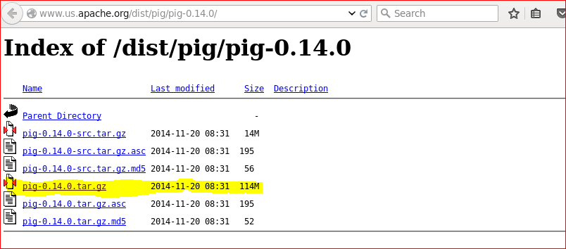

**Download the highlighted tar file.**

**After download it will be saved in download folder.**

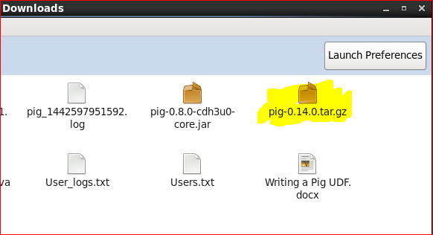

**Go and untar the file by right clicking on it and select extract here option.**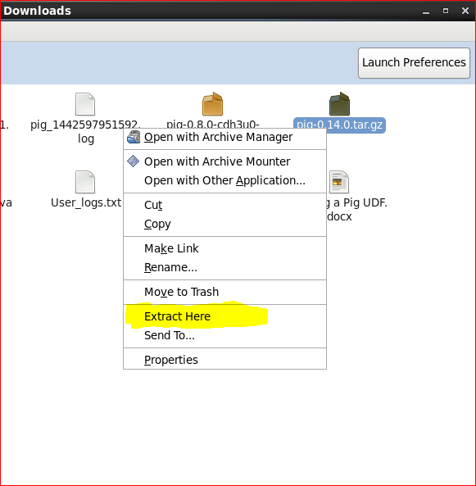

**Once the file is extracted.**

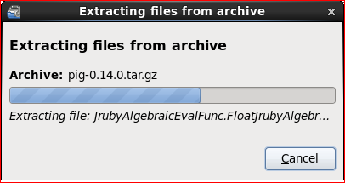

**It will be shown as directory. Move it to $HOME directory.**

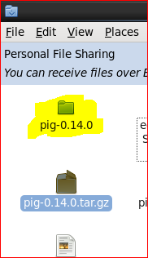

**Open the Terminal.**

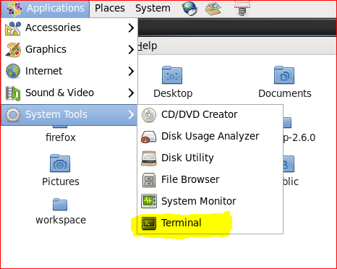

**Open .bashrc file to edit using sudo gedit .bashrc command.**

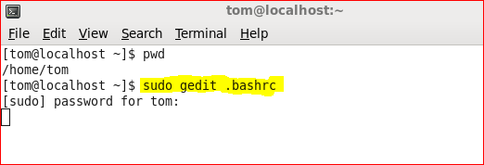

1. **Create following environment variables in .bashrc file:**
   1. **export PIG_INSTALL=/home/user/pig-0.12.0**
   2. **export PATH=$PATH:$PIG_INSTALL/bin**

**3. export PIG_CLASSPATH=$HOME/Hadoop-2.6.0/sbin**

**And do remember to save file.**

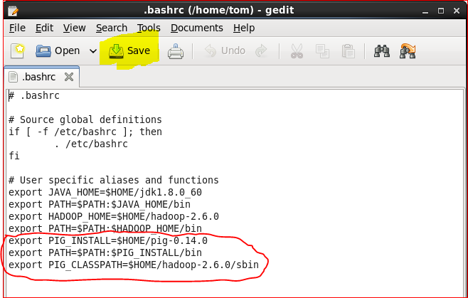

**Run command source .bashrc to update the system.**

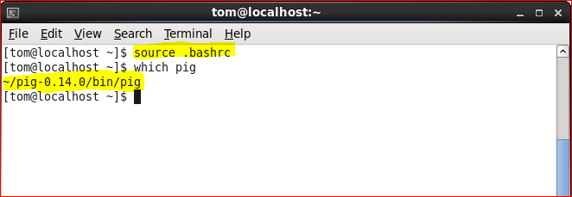

**Type pig to go into grunt shell.**

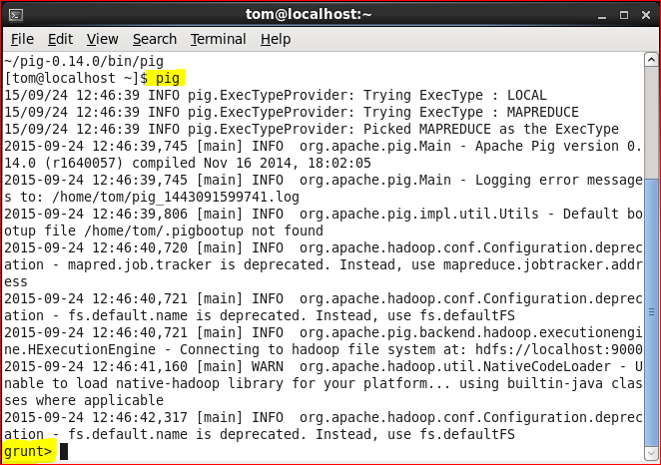

**Congratulations!!! PIG is now installed in your system.**